Improving Code Quality

Name | P-Number | Email
Manoj Kumar | 19961104-2517 | mbvq17@student.bth.se
Mandalaneni
Sai Nidhin | 19970831-5495 | kasd17@student.bth.se
Kaminipaty
Rahul Varma | 19950528-1353 | darh17@student.bth.se
Danduluri
Karthik | 19940916-0133 | thkt17@student.bth.se
Thupalle

Introduction:

Software quality is a major aspect of a software that concerns with the assurance of the software meeting the requirements specified by the customers and all the other stakeholders of the software project. And Software Quality Management is the process that is implemented to make sure that the software quality of the product is up to par by the time it comes out to the customers and users. Software Quality is one of the most significant aspects of a software. During the development of a software, the process of software quality management is implemented in order to make sure that the software quality is always going to be up to par. One of the best strategies to improve software quality is the GQM+ strategy. The GQM+ strategy is the strategy or process that uses specific goals, questions and metrics to try and improve software quality. In this paper, we aim to improve the software quality of an open source software, ‘Java Master’ code [1] using GQM+ strategy.

The tools used to find the code smells are Visual Code Grepper [2] and CheckStyle [3].

QUALITY REPORT GENERATED:

From the VCG tool, we obtained the following code smells.
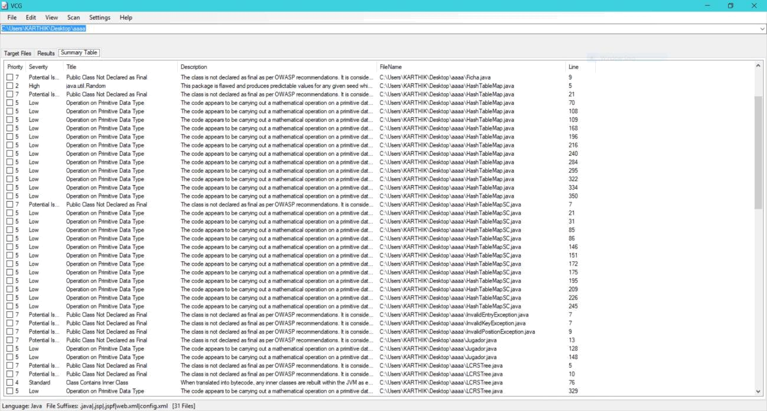

The description of the smells obtained through VCG tool are as below,

POTENTIAL ISSUE: Potentially Unsafe Code - Public Class Not Declared as Final

The class is not declared as final as per OWASP recommendations. It is considered best practice to make classes final where possible and practical (i.e. It has no classes which inherit from it). Non-Final classes can allow an attacker to extend a class in a malicious manner. Manually inspect the code to determine whether or not it is practical to make this class final.

Line: 9 - C:\Users\KARTHIK\Desktop\aaaa\BoundaryViolationException.java public class BoundaryViolationException extends RuntimeException {

Line: 7 - C:\Users\KARTHIK\Desktop\aaaa\HashTableMapSC.java public class HashTableMapSC<K,V> implements Map<K,V>

LOW: Potentially Unsafe Code - Operation on Primitive Data Type

The code appears to be carrying out a mathematical operation on a primitive data type. In some circumstances this can result in an overflow and unexpected behaviour. Check the code manually to determine the risk.

Line: 22 - C:\Users\KARTHIK\Desktop\aaaa\Color.java
result = prime * result + ((color == null) ? 0 : color.hashCode());

Line: 70 - C:\Users\KARTHIK\Desktop\aaaa\HashTableMap.java this.scale = rand.nextInt(prime - 1) + 1;

HIGH: Potentially Unsafe Code - java.util.Random

This package is flawed and produces predictable values for any given seed which are easily reproducible once the starting seed is identified.

Line: 4 - C:\Users\KARTHIK\Desktop\aaaa\Dado.java import java.util.Random;

Line: 5 - C:\Users\KARTHIK\Desktop\aaaa\HashTableMap.java import java.util.Random;

STANDARD: Potentially Unsafe Code - Class Contains Inner Class

When translated into bytecode, any inner classes are rebuilt within the JVM as external classes within the same package. As a result, any class in the package can access these inner classes. The enclosing class's private fields become protected fields, accessible by the now external 'inner class'.

Line: 75 - C:\Users\KARTHIK\Desktop\aaaa\LinkedTree.java
private class LinkedTreeIterator<T> implements Iterator<Position<T>>

Line: 76 - C:\Users\KARTHIK\Desktop\aaaa\LCRSTree.java
private class LCRSTreeIterator<T> implements Iterator<Position<T>>

STANDARD: Potentially Unsafe Code - Class Contains Public Variable:
InvalidKeyException

The class variable may be accessed and modified by other classes without the use of getter/setter methods. It is considered unsafe to have public fields or methods in a class unless required as any method, field, or class that is not private is a potential avenue of attack. It is safer to provide accessor methods to variables in order to limit their accessibility.

Line: 29 - C:\Users\KARTHIK\Desktop\aaaa\Map.java public V put(K key, V value) throws InvalidKeyException;

Line: 37 - C:\Users\KARTHIK\Desktop\aaaa\Map.java
public V get(K key) throws InvalidKeyException;

STANDARD: Potentially Unsafe Code - Class Contains Public Variable:
BoundaryViolationException

The class variable may be accessed and modified by other classes without the use of getter/setter methods. It is considered unsafe to have public fields or methods in a class unless required as any method, field, or class that is not private is a potential avenue of attack. It is safer to provide accessor methods to variables in order to limit their accessibility.
Line: 20 - C:\Users\KARTHIK\Desktop\aaaa\Tree.java
public Position<E> parent(Position<E> v) throws InvalidPositionException,

BoundaryViolationException;

IDENTIFICATION OF QUALITY ATTRIBUTE FOR IMPROVEMENT:

Motivation: We have selected ‘Maintainability’ as the quality attribute to improve because maintainability is the key feature in any code to know how the software gets affected by frequent changes. Having high maintainability implies a high-quality software as it can be easily understood to analyse and make changes to it in the future easily.

GQM+ strategy to improve maintainability:

GOAL

- To improve the maintainability of Java Master.

QUESTIONS

Q1 How can the complexity of the source code be reduced?

Q2 How can the source code be improved for better maintenance?

 |  | METRICS
M1 |  | Lines Of Code (LOC)
M2 |  | Cyclomatic Complexity (CC)
 | Table: Goal, Questions and Metrics

Q1. How can the complexity of the source code be reduced?

This question can be answered by Lines Of Code (LOC), Cyclomatic Complexity (CC)

We can decrease the complexity in the source code by using simple ways of optimization techniques instead of normal source code.Optimization techniques include the way of using the data structures,tweaking,memorization etc. From the previous assignment, LCRSTree.java, HashTableMap.java etc are the examples in in our code which are having more complexity. Therefore using simple methods instead of large methods in the code will help in decreasing complexity.

Q2. How can the source code be improved for better maintenance?

Maintainability answers how maintenance can be improved.

If there are more comment lines of code it will affect maintainability. Some classes in ‘Java Master’ are having unnecessary comment lines of code. Here unnecessary lines of codes means the lines of code which does not effect the output even in their absence.Hence, we can decrease these comment lines in the code so that the maintainability increases. Maintainability depends on both cyclomatic complexity and comment lines of code. Lesser is the complexity, more is the maintainability.

Q3. How readability have impact on maintainability?
Readability is also one of the factor that effects maintainability.
It means the quality that enables the users to see the code to be implemented in a correct way.If the code is easily understood by the user it is very easy for him to complete the task.Readability can be measured by readability index.It is the measure of the reading the code.If reading of code(Readability Index) is easy then maintainability is high.If readability index is less then maintainability is less.Hence this is in brief about readability.

Conclusion:

We have obtained the Goal Question Metrics and according to our goal, research questions were formulated and answered. We have analysed the source code using metrics Lines Of Code (LOC), Cyclomatic Complexity (CC). We found classes that are having high complexity and comment line of code in order to increase the maintainability. We can be successful in increasing the maintainability of the source code if we make changes in the above mentioned metrics.

References:

- https://github.com/rainer85ah/Java?files=1

- https://sourceforge.net/projects/visualcodegrepp/

- http://checkstyle.sourceforge.net

- Basili V. et al. (2014) GQM+Strategies in a Nutshell. In: Aligning Organizations Through Measurement. The Fraunhofer IESE Series on Software and Systems Engineering. Springer, Cham

- N. Tsuda et al., "Iterative process to improve GQM models with metrics thresholds to detect high-risk files," 2016 IEEE Region 10 Conference (TENCON), Singapore, 2016, pp. 3813-3816.

